**DWH & e3Learning Data Interface**

**Operation Instruction**

Contents

1. Background 1

2. ETL Package 2

2.1 SSIS Package Source 2

2.2 Main Part for ETL 2

3. Automate Job 3

3.1 Deployment Server 3

3.2 Job Setting 3

| **Version Number** | **Version Date** | **Revised By** | **Description** | **Filename** |
| --- | --- | --- | --- | --- |
| 1.0 | 30/11/2017 | Jerry Shen | Created |  |
|  |  |  |  |  |
|  |  |  |  |  |

# Background

Basing on requests from e3learning project team, DWH team developed and deployed ETLs to extract required data, generate it into csv file and upload it to e3learning ftp server.

This job is mainly based on employee information which active directory data from HRIS data mart.

It is a automate job and runs at 7:00PM daily.

# ETL Package

## SSIS Package Source

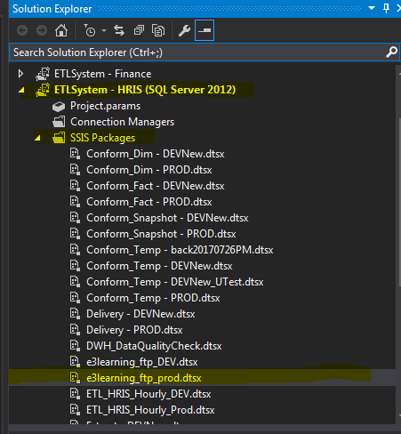

## Main Part for ETL

There are three steps in this ETL like below:

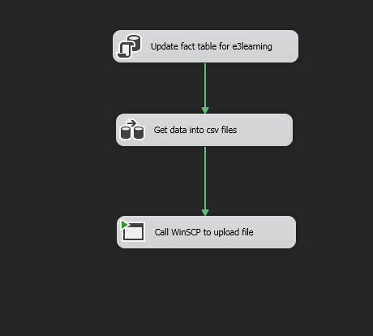

* Step1: update fact table
* Step2: generate csv file
* Step3: upload file to e3learning ftp server: use WinSCP as ftp client tool.

# Automate Job

## Deployment Server

* Server: Az-sqlbi01
* Folder: \\az-sqlbi01\c$\e3learningdata

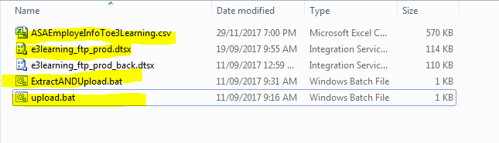

* Use Remote Connection Control to login to this server

## Job Setting

Using Windows Task Scheduler to schedule the job run daily from 7:00PM

